Zenshiro Game Design Document
An epic battle between Zenshiro the Samurai and a Dragon, in space. Zenshiro is a top down shoot ‘em up created by Sean McLoughlin, Calvin Kwok, Patrick “Smee” Buford, Curtis Antolic, Austin Drexler and Jacob Kniphing.
Game Overview
The concept behind Zenshiro is that there is more the shoot ‘em up genre can accomplish while set in space, despite popular opinion. The game features a Samurai named Zenshiro, running along the back of a giant robotic dragon, who is flying through space. Along the way to the dragon’s head, Zenshiro will face enemies ranging from stationary dragon head turrets to enemy samurai trying to protect their dragon, along with numerous traps and obstacles he will have to avoid.
The game will start with Zenshiro defending his town against the dragon and subsequently jumping onto its back in order to slay it once and for all. Players will scale the dragons back automatically but will be able to move left, right, forward and back. Players will also have the ability to jump in order to avoid obstacles and enemy projectiles. However, if they jump at the wrong time, a burst of fire from the dragon’s mouth will take them out.
Along the way there will be a mini boss consisting of two dragon head turrets where the scrolling screen stops to allow Zenshiro to do his work. After destroying the two dragon head turrets, the scrolling resumes as Zenshiro continues his way to the dragon’s head. Upon reaching the head, the final boss fight will occur. Players will have to dodge the dragon’s fiery breath and laser eyes in order to defeat the robotic beast. Upon defeating the dragon the game ends with Zenshiro riding the headless dragon’s body back to earth, presumably to a hero’s welcome from his town.
ALTERNATE ENDING IDEA: Just as Zenshiro is about to land the killing blow, the dragon wakes up from a really bad dream.
Abilities
When Zenshiro swings his sword horizontally he swings it in an arc 180 degrees in front of him, this arc deflects all bullets back to their source, as well as doing fatal damage to any enemies it hits. This attack has a small cool down afterwards in order to prevent players from spamming it and becoming invincible.
When Zenshiro swings his sword vertically it sends out a spinning blade that acts as his primary ranged attack. Two to three shots from this attack are enough to take out most normal enemies.
Zenshiro also has the ability to jump up off the dragons back for a brief period, in order to avoid enemy projectiles and other obstacles.
Enemies
Samurai: Ground based troops who have a projectile and melee attack.
Jetpack Samurai: Samurai who attack with bombs and sword slashes from the air.
Oni and Kappa: Melee enemies in service of the evil Samurai. Kappa have the ability to fly.
Turrets: The stationary guns in this game don’t pose much of threat alone, however they are often found in groups of 6 or more. The shoot lasers in long streams. Three shots from Zenshiro’s ranged attack will take out one gun
Mini Boss: Dragon Head Turrets, these take ten shots from Zenshiro’s ranged attack to destroy and they’re the only enemy besides the bosses that cannot be one hit killed with Zenshiro’s melee attack. It will take two strikes with the sword in order to take out a dragon head turret but fighting them at such short range will be tough.
Dragon Head: The dragon head is the final boss. He spits fire in various ways, waves, pillars, fireballs, he shoots lasers out of his eyes and bites at Zenshiro if he gets too close. In order to damage the dragon, he will have to shoot the dragon’s eyes in order to get him to open his mouth. Shooting the dragon in the mouth damages it. His eyes have limited health and once they are shot enough, they will explode, disabling the eye lasers. Once both eyes are destroyed, the dragon’s mouth is permanently open and susceptible to damage; however, his fire attacks increase in frequency. Once the mouth is destroyed, the dragon’s head explodes and Zenshiro rides the dragon’s body back to earth.
Enemy Formations
Flying Enemies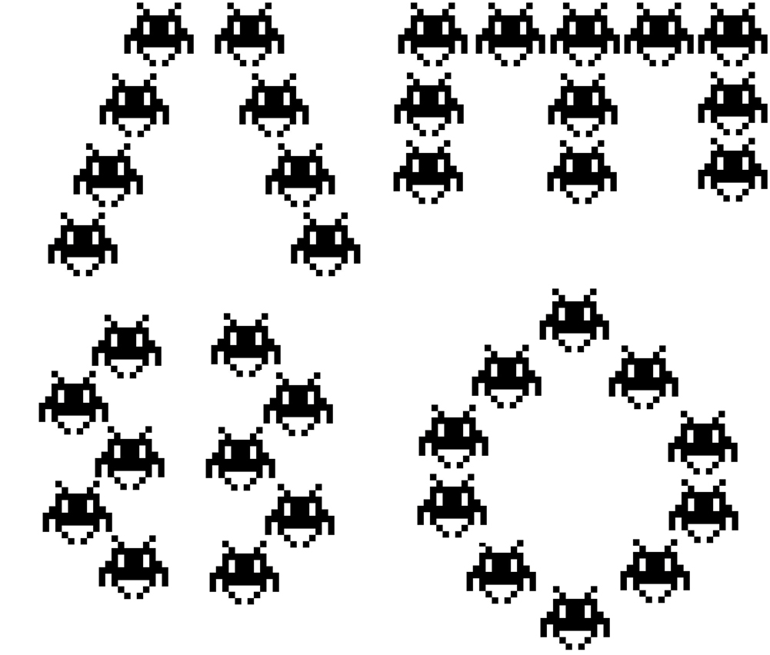

Obstacles
These objects are indestructible and will require Zenshiro to jump over them with his jetpack.
Lava: The bursts of fire from the Dragon’s mouth have melted parts of the Dragon’s armor, turning it into molten lava. These pools of death must be avoided at all cost.
Dragon’s Claws: Occasionally the dragon’s claws will appear and try to swipe at Zenshiro as he makes his way up the dragon’s back.
Dragon’s Fire: Every so often, the dragon will send a blast of fire down his back, Zenshiro will have to either jump to avoid it, or stay grounded if the blast is in the air.

